**Design Report**

**F22-21-BOE1**

Dylan Houghland, Nicolas Forcade-Perkins, Mason McFarland,

Benjamin Trewin, Samuel Kash

April 25, 2023

**Southern Illinois University Carbondale**

**Saluki Engineering Company**

**Southern Illinois University Carbondale**

**College of Engineering**

**Design Report**

**F22-21-BOE1 Design Team**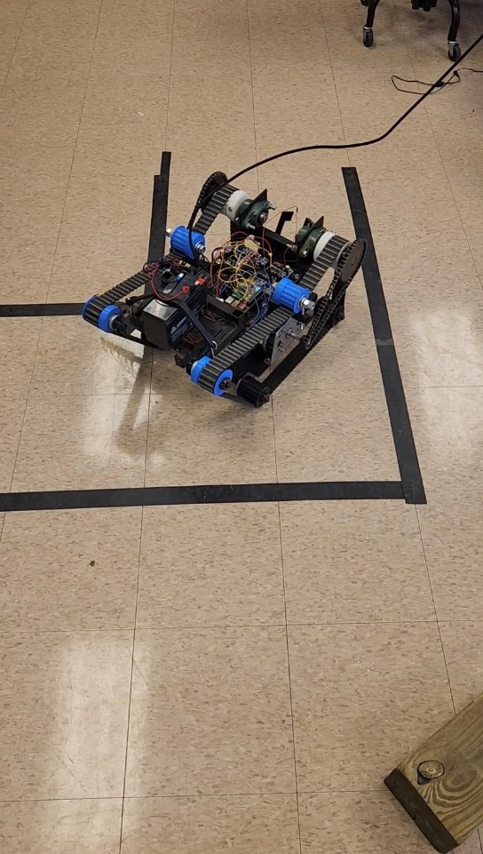

Members:

Dylan Houghland (CE), Nicolas Forcade-Perkins (CE & MATH),

Mason McFarland (CE), Benjamin Trewin (ECE), Samuel Kash (EE)

Senior Design II (ECE495)

Professor Cubley

|  |  |
| --- | --- |
| **Proposer:** | **Client:** |
| Saluki Engineering Company  Project Number: F22-21-BOE1  Product Owner: Benjamin Trewin  Email: [benjamin.trewin@siu.edu](mailto:benjamin.trewin@siu.edu) | Boeing Co.  Project Codename: Big Boeing Brand  FTA: Evan Ehrenheim  Email: [evan.j.ehrenheim@boeing.com](mailto:evan.j.ehrenheim@boeing.com) |

# Cover Letter (NFP)

F22-21-BOE1

E0238

1230 Lincoln Drive

Carbondale, IL 62901

Senior Design Professors

Saluki Engineering Company

Southern Illinois University

1230 Lincoln Drive

Carbondale, Il 62901

Apr 25, 2023

Dear senior design professors,

Our senior design team, F22-21-BOE1, has completed all work in regards to the Search and Rescue robot. The final prototype is able to maneuver with low latency, scale obstacles, maneuver through a maze autonomously, and retrieve objects. All work on the project will be done exclusively by the members of the group. We met weekly with our FTA, Evan Ehrenheim, who is representing Boeing for this project for guidance.

The purpose of this project was to build an innovative search and rescue robot that can overcome large obstacles, detect metal, and be partially autonomous. We have successfully designed a robot that accomplished a majority of these tasks. Although it was unable to navigate over some larger objects, it was generally very successful in regards to our success metrics. We stayed under budget by about $200 and successfully completed the project by the deadline. During this competition, we displayed our prototype and demonstrate its functionality. Our robots was scored independently based on the grading criteria Boeing has laid out for us.

On behalf of the F22-21-Boeing team 1, I would like to thank Saluki Engineering Company Leadership and Boeing for allowing us the opportunity to complete this project, specifically Prof. Cubley and Evan Ehrenheim. If you have any questions or concerns about our proposal, please feel free to contact me, Nicolas Forcade-Perkins, at [nicolas.forcade-perkins@siu.edu](mailto:nicolas.forcade-perkins@siu.edu) or 480-724-0729. Thank you for considering our design.

Regards,

Nicolas Forcade-Perkins, F22-21-BOE1

**Table of Contents**

Cover Letter (NFP) 4

Introduction (BT and NFP) 8

Requirements (NFP) 9

Major Design (NFP) 9

Courses (NFP, BT) 10

Standards (NFP) 10

Judgement (NFP) 10

Constraints (NFP) 11

Sprints (NFP) 11

Tools (BT) 12

Overall Design Description (BT, SK, DH) 12

Subsystem Development – Update with final result from this semester 13

Chassis (BT, SK) 14

Movement System (BT, SK) 15

Claw(DH) 17

Metal Detection (MM) 17

Electrical Circuit Layout (BT) 18

Control Program (NFP, BT) 19

Autonomy Program (NFP, DH) 20

Conclusion (DH and NFP) 21

Appendix A: References (All) 22

Appendix B: Block Diagram (BT) 23

Appendix C: House of Quality (DH) 24

Appendix D: Organizational Chart (DH) 25

Appendix E: Sprint Breakdown (DH) 26

Appendix F: Budget (NFP) 27

Appendix G: All Design Work 28

Metal Detector Circuit/Implementation (MM) 29

Wheel Physics (BT) 30

3D Models of Chassis (BT) 32

Basic Motor Controls Code (BT) 34

Circuit Layout (BT) 35

Appendix H: User Manual (NFP and BT) 37

Appendix I: Technical Manual (NFP) 39

Appendix J: Parts Plan (NFP) 42

Appendix K: Communication (BT) 42

# Introduction (BT and NFP)

The overarching problem our design team was tasked with is designing a search and rescue robot which has several features. The robot must have the ability to climb over a 6’’ post, pick up objects, turn and maneuver quickly, detect metal, and operate semi-autonomously. These guidelines were set to make the robot as effective as possible when searching in difficult terrain such as rubble.

This problem of course fits into a broader preexisting body of knowledge of search and rescue robots. However, our robot has a constraint of being constructed at an extremely low $1000 budget as compared to leading companies with millions of dollars.

Some of the motivation behind this project and likely some of Boeing’s motivation to fund us is to see if students can create unique and creative solutions that work very well within search and rescue robots. If some feature of our final product works very well, perhaps it can be implemented in more complex designs to help expand this field of robotics. Further, because our budget was so low, if a feature does work extremely well, perhaps the cost of future robots can go down. Economically if the cost of robots dropped more of these search and rescue machines could be produced. Further, these robots can quite literally save lives, an extremely positive societal effect. Environmentally, if we can manufacture our robot in a relatively green way and utilize energy within the robot cleanly, we will have a positive impact on the planet. Globally, our design could have very positive outlooks on many different aspects of our world, including economically, socially, and environmentally.

Our overall robot can be described in terms of a number of individual designs which will ultimately be combined. The designs or subsystems that need to be completed include, the chassis, the movement system, the pickup system, the metal detector, the electrical layout, the control program, and the autonomy program. Of these smaller pieces, the chassis and movement systems are fully completed The pickup system or claw is fully functional and can pick up a can. The metal detector is attached to the claw and can detect successfully around 80% of the time. The electrical layout has been completed using motor controllers and switches. The controller utilizes a GUI used on an Android phone over a Bluetooth connection in order to send signals to the Pi. The robot can detect objects using a Machine Learning model on the Pi. The robot is able to move autonomously through the maze with about a 75% success rate using an algorithm we developed and infra-red sensors.

Subsystem Completion:

* Chassis à Completed
* Movement System à Completed
* Pickup System à Completed
* Metal Detection à Completed
* Electrical Layout à Completed
* Control Program à Completed
* Autonomy Program à Completed

# Requirements (NFP)

## Major Design (NFP)

This is a major design experience. It will take around 8 months for five students working ~10 hours per week. It is a company-sponsored project and thus will help to solve a problem in industry. It will strive to help showcase the talents of SIU engineers to a Fortune 500 company. Within the project, we will utilize the talents of a diverse group that includes Electrical Engineers, Computer Engineers, and Math majors. The project will have three major tasks: building the robot, programming the controls for the robot, and implementing partial autonomy. Our goal is to have the first task fully completed by the end of the first semester with work having begun on the second part.

## Courses (NFP, BT)

The courses that have been most beneficial and applicable toward our project are ECE 321, ECE 296, ECE 345, and ECE 385.

ECE 321, Intro to Software Development: A class where we learned how to program using C. We will apply this course and the development practices learned in it while developing the code to run the robot.

ECE 296, Intro to Software Tools and Robotics: A class where we learned Python and how to build robotic systems. We learned how to program Arduino's and Raspberry Pi's in this class which will be helpful in developing controls for the robot.

ECE 345, Electronics: This class has been helpful in helping us plan the circuit design for controlling the motors and creating the metal detector.

ECE 385, Electromechanical Energy Conversion: This class helped us understand some of the theory behind motor function and their power requirements. Further, by utilizing information within this class we purchased quality motors and motor controllers to move our robot.

## Standards (NFP)

We will incorporate the IEEE standard of IEEE 802.15.1-2002. This is the standard that encompasses wireless communication, specifically Bluetooth. We will use this standard to guide how our robot communicates with the controller we build.

We will incorporate the IEEE standard of IEEE 1625-2008. This is the standard that determines how rechargeable batteries should be used on portable devices. This is important as we plan on using rechargeable batteries to power our robot in order to save on costs and environmental footprints.

We also plan on incorporating the standards of IEEE 26513 and IEEE 1118-1990 next semester when we finish programming the controller. IEEE 26513 standard give directions on how to program and test code while IEEE 1118-1990 is the standard for serial communication on microcontrollers.

## Judgement (NFP)

Below is a list of each design judgement we have considered.

Global: Since our robot is a search and rescue robot, it can potentially have global impacts as it is able to navigate and retrieve objects from areas that are not safe for humans. This will allow human lives to be saved and have a positive global impact.

Economic: We must design our robot with a budget of under $1000. We chose to use products from all over the world when ordering parts in order to help contribute to the health of the global economy. This helped us to have cheaper parts, even if the shipping time took a little longer.

Environmental: We used rechargeable batteries which will reduce waste. We used as many recycled parts as possible in order to reduce our carbon footprint. We also decided to donate a large portion of the parts on the robot to next year’s program in order to reduce waste as much as possible.

Societal: We made judgements on the societal impact of our robot when deciding how large to make the claw. We were limited in space, but by increasing the size of the claw we could increase the size of objects it is able to pick up. In theory, being able to pick up larger objects would allow it to be used in more situations and hopefully save more lives. Thus, we made the claw as large as feasible within the constraints of the project in order to maximize the positive social impact.

## Constraints (NFP)

Below is a list of each design constraint we have considered.

Economic: We must design our robot with a budget of under $1000.

Environmental: We used rechargeable batteries which will reduce waste. Our robot will not produce any greenhouse gases and thus will not pollute.

Social: Our robot doesn't have any social constraints.

Political: Our robot doesn't have any political constraints.

Ethical: Because our robot will be semi-autonomous, we will ensure that there is nothing unethical in any programs we produce. Further, we will document open-source code utilized and not play it off as our own developments.

Health and Safety: The goal of the robot is to be able to search and rescue small objects. This could be used in situations where it isn't safe for a human to enter.

Manufacturability: Our robot needs to be able to be built in under 1 year. Further, it should ideally be built to have a final volume <2ft3.

Sustainability: We use rechargeable batteries which will reduce waste. We will also donate our robot at the end to the ECE department so that the parts can be reused next year.

## Sprints (NFP)

This project was an iterative process. This semester we broke the project into three sprints.

In sprint 1, our focus was to fully complete the chassis, build the claw, and actually get the robot moving. We were able to accomplish all three of these goals and also get started on building the code for the controller.

In sprint 2, our focus was to finish most of the code for the controller, get all the needed parts mounted on the robot and integrated into the code. We were able to have a fully-functional claw mounted on the robot and controlled over a Bluetooth connection by the end of this sprint. In addition, the necessary code for the controller was finished and we were able to start working on adding features to enhance it. We also completed the metal detector in this sprint and mounted it to the claw.

In sprint 3, our focus was on object detection, autonomy, and fixing any issues that arose before the final test. By the end of this sprint, we had created an object detection model that sent images to a more powerful computer that then ran a PyTorch model in order to classify which objects were in an image and locate where those objects are within the image. We also were able to mount sensors onto the robot and complete both left and right turns when navigating through the maze autonomously. It was inconsistent, but is able to get through any maze completely autonomously.

## Tools (BT)

Below is a list of all the major tools we have used and plan to use for our project.

Autodesk Fusion 360: We used this 3D modeling software to help solidify our ideas of what the robot’s body should look like while remaining within our size constraint. It was particularly helpful in determining the size of the treads we needed. See ‘Appendix G: All Design Work à 3D Models of Chassis’ and ‘Appendix G: All Design Work à 3D Model of Pulley Backordered’ for work created within this program.

PSpice: This software will be used in order to validate and simulate the circuit we are planning on using to detect metal.

Ubuntu Server 20.04.5 LTS + ROS Noetic: This Ubuntu OS version has been imaged onto the raspberry pi. This particular image allows us to also install ROS Noetic which has been encouraged to be used within our design.

Raspberry Pi OS Lite 5.15: Because the previous OS image has no desktop and is a bit difficult to develop on, this Raspbian image may instead be used without ROS implementation. Either way, this OS will be used for rapid design and test.

Visual Studio Code: This software is a simple environment for creating and debugging code. Specifically, we plan to use it for writing python scripts which will eventually control the robot through the raspberry pi.

Physical Tools: During the creation of the chassis and physical components on our robot, several machining tools were used. This included but was not limited to a band saw, grinder, welder, squares, 3D printer, and much more. See appendix ‘Appendix G: All Design Work à Chassis Build’ for images of the chassis.

# Overall Design Description (BT, SK, DH)

The overall goal of this project was to design a search and rescue robot that included a variety of functions. The robot must be able to scale a 6” post, traverse sand, detect metal, navigate autonomously through a maze, and pick up objects, among other requirements. This is a major design project since there is no template or parts list to follow, all we have is a $1,000 budget and the above tasks.

As a team, we created the House of Quality (HoQ). The purpose of this document was to help us decide what constraint we should prioritize reaching after our sprints. It also identified some of the most important items/concepts toward reaching these priority goals including horsepower, a Raspberry Pi for control, and a track system to move the robot. This HoQ helped us to organize our priorities for the semester and we now have a track system and a Raspberry Pi as our controller.

To identify what our team will see as a successful finished product, please note the priority given to each constraint below (A being high priority, F being low priority)

* Less than $1000 à A
* Less than 0.5 sec latency à C
* Less than 5 sec 180° turn à C
* Scale 6’’ log and post à B
* Carry items à C
* Less than 2 cubic feet volume à B
* Metal detection capability à D
* Maze travel autonomy à A
* ROS integration à F
* Controlled through app à C

A successful final design will meet or nearly meet all A priority design constraints. Further, it will also meet or nearly meet at least four of the B and C tier constraints. Additional constraints met is a bonus. Nearly met is defined as the 10-point column in the Boeing competition scoresheet found in ‘Appendix K: Communication’.

Our proposed solution will utilize tracks to get over the 6’’ obstacle with gear ratios to increase the torque of our motors. This is a unique design choice as the previous Boeing teams analyzed used wheels and did not use gear reduction. Next, the finished product will have a claw to pick up nearby objects and a metal detection circuit to detect metal. These devices will both be attached to the frame of our robot and potentially extend out. The programming and control aspects of the design will be run on a raspberry pi. Lastly, autonomy will use sensors to detect a maze and navigate through it. Further information on each subsystem is written in the section to follow. Refer to ‘Appendix B: Block Diagram’ for a visual representation of these subsystems.

# Subsystem Development – Update with final result from this semester

## Chassis (BT, SK)

The chassis subsystem is our design of the body of the robot. The main goal for the chassis is to hold all the parts of our robot. We had to collaborate as a team to determine what we wanted the robot to look like. Ben Trewin used Fusion 360 to design different iterations of the robot. Since we needed to get over a 6” log we knew the front had to stand higher than 6” to allow the robot to make it over the log. The next consideration was to make sure we had sufficient surface area on the ground. We made sure to use wide tracks which mostly aids with additional traction at angles but also helps the robot move through sand. Yet another consideration within the design was trying to stay within a two-foot cubed volume constraint.

With the models from Ben Trewin, Samuel Kash began constructing the frame, which would turn into the chassis by using 1” square tubing of 1/8” wall. While this tubing is heavy it provides a very strong base. The robot chassis is mostly complete this semester. To make the frame into a chassis it needs to house all the subsystems and we must wait on their individual completion as sizes may change. The other part that needs to be finished is the track tensioning scheme. Samuel Kash has an idea on how to implement this and plans to complete it by the end of the first sprint.

The chassis was mostly completed during the first semester. Unfortunately, when we went to 3D printed rollers all the way around we ran into the issue of it was too big to comfortably fit the track. This posed 2 issues, the first being the track not fitting and the second being the robot was then over the size constraints. To mitigate this we had to cut the frame apart and trim some height and length out of it. Upon re-assembly the frame twisted and made the parts not all line up correctly. Samuel Kash then had to cut the frame back apart to straighten it and reweld. After overcoming those obstacles, the frame went together well. To give it the finishing touches we added a bracket for the plexi-glass as well as a bracket to attach the tensioning system. Lastly, we added a battery tray on top to hold our battery up and out of the way.

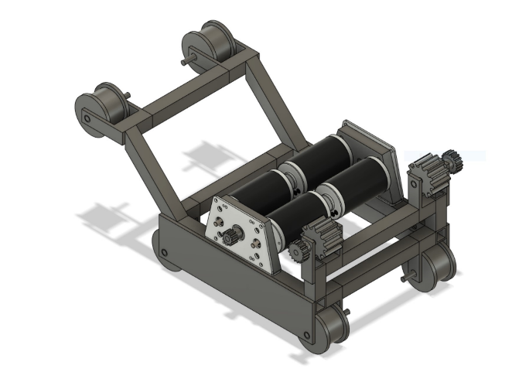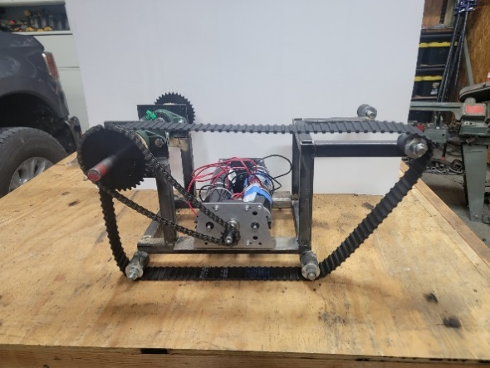

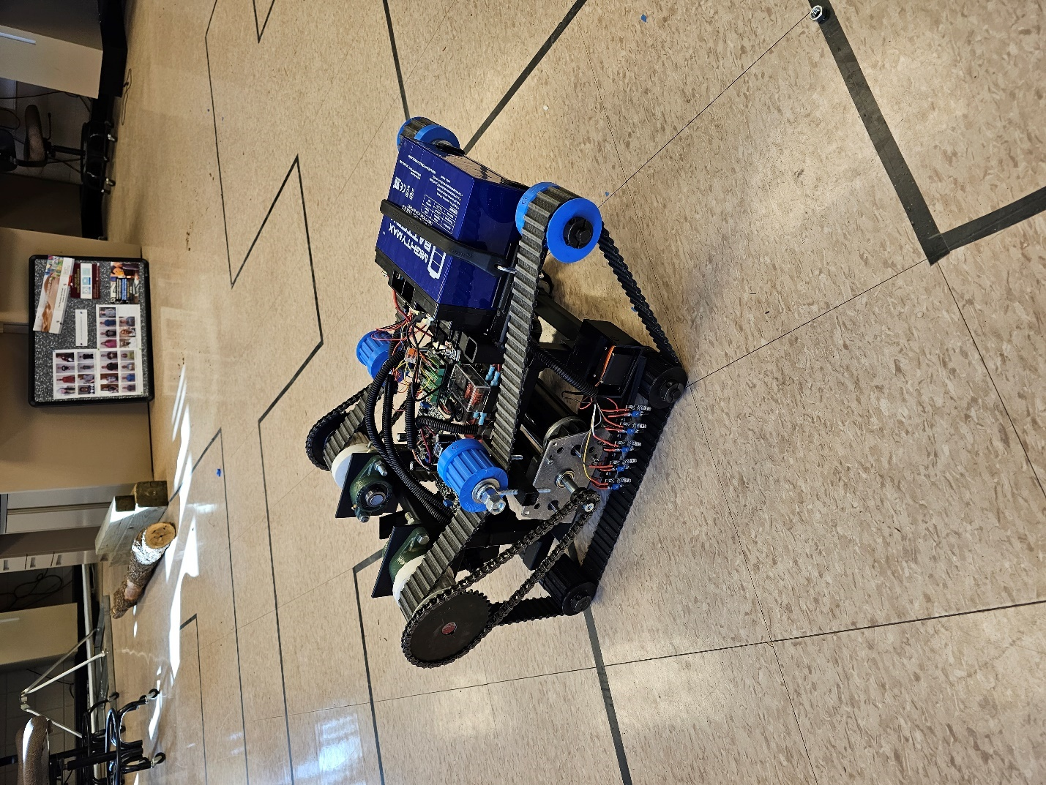

For additional images see ‘Appendix G: All Design Work à 3D Models of Chassis’ and ‘Appendix G: All Design Work à Chassis Build’.

## Movement System (BT, SK)

The movement subsystem is our design for moving the robot. This subsystem was fully completed this semester apart from a single part which is still needed to fully function. This was ordered months ago but is on backorder until January. Experimentally we have 3D printed this part, see ‘Appendix G: All Design Work à 3D Model of Pulley Backordered’. The design constraints related to this subsystem is the ability for our robot to get over a 6’’ post and the ability for it to turn 180° in less than five seconds. Once some basic control programming is done, we will be able to test this subsystem to see if it meets constraints and therefore the goals set out.

A fair amount of research and analysis was done regarding this subsystem. First and foremost, we researched how the robot we planned to build should move and be able to maneuver over large obstacles. After watching some physics lectures regarding wheels, Ben Trewin reached the conclusion that to physically get over a curb of six inches, a wheel’s diameter must be over double that height [4]. Further, with wheels of this size, keeping within the two feet cubed volume constraint described in the chassis subsystem was impossible. Hence, we decided to research tank treads which don’t share this size limitation. See ‘Appendix G: All Design Work à Wheel Physics’ for mathematical work.

After establishing our treads, we started researching motors. Samuel Kash ultimately found the motors that we selected which would have enough torque relative to our predicted robot weight to climb a 45° angle if gear ratioed correctly [5]. To reach this desired torque we ordered a gear box that utilized a gear reduction as well as two motors to drive a single output shaft per side. In total we ordered four motors and two gear boxes to get our desired torque. Additional gear reduction takes place between the motor output shaft and the pulley (tread spinning) shaft by utilizing chain and sprockets.

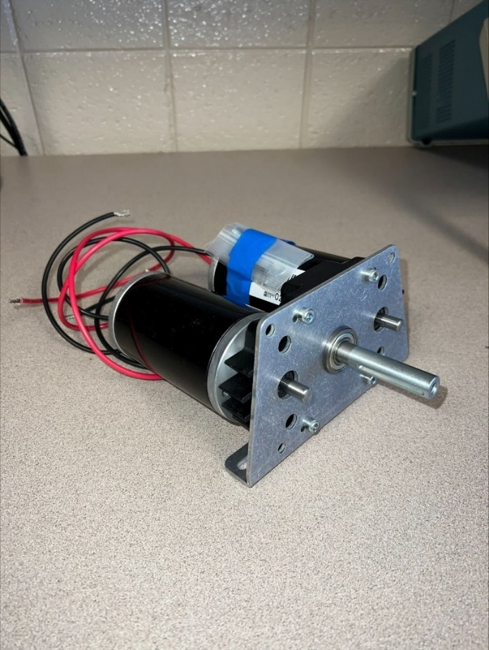

After the motors arrived, we realized that the motors only had two wires. Typically to control this sort of motor, a motor controller circuit board is used to control the motor’s speed via pulse width modulation and direction via an H bridge. These devices are used as an interface between the microcontroller and motor because most microcontrollers cannot handle the 12V our motors need. After lots of further research, Ben Trewin found a motor controller microchip that will work with our designs. This was a complicated process because our motors can draw extremely high current when met with mechanical resistance, which not all motor controllers can handle. After further research we found a few sources recommend using motor controllers that can handle a quarter of the stall current, and thus ultimately the Cytron microchips were purchased [6]. Utilizing knowledge from ECE385 helped us understand statistics listed on motor controllers and motors and assisted in our decision of products.

At the beginning of the semester, we were delt a hefty blow when the vendor canceled our order for the drive rollers. In an effort to not get further behind, Dylan Houghland found a free-source model of the roller and was able to 3D print it for us. This solved our issue very well and we were ready to proceed. In order to transfer the rotational movement from the motor shaft we utilized a ¾” axle that was held to the robot with 2 pillow block bearings. To attach the belt drive pulley we chose to drill a hole through the pulley and shaft and attach a bolt that goes through everything, this way when the shaft rotates the drive pulley will as well. Since the motors are mounted on the bottom of the robot we connected the gear box output shaft to the drive axle via a #35 roller chain. By utilizing the chain we were able to do a 2:1 gear reduction.

The drive rollers are just 2 out of 10 rollers. After a few trials and errors we ultimately came to the consensus to 3D print the other 8 pulleys. They have been holding up much better than expected. The biggest issue with using tracks is keeping them tight. To mitigate this issue we designed a system that uses standard eye-bolts to offer infinite adjustability by tightening the nut on it draws the printed roller down against the belt.

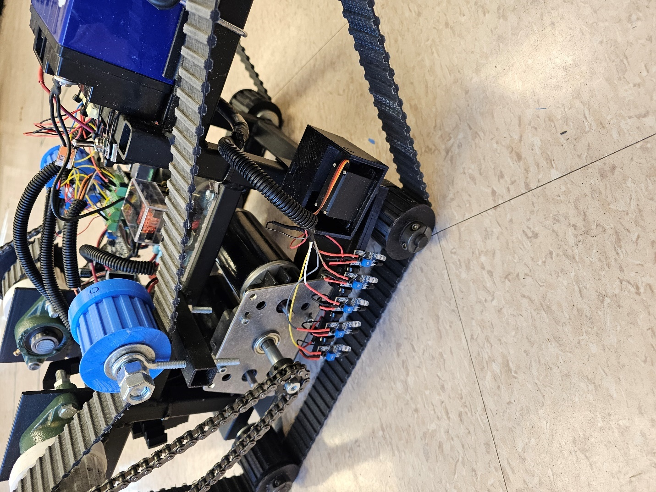

The movement subsystem is inherently related to the chassis which it needs to be able to move. Additionally, movement of the motors will be controlled using the control program subsystem and lastly the motors need to be connected to power with the electrical circuit layout subsystem.

## Claw(DH)

The goal of the claw is to be able to pick up a foam cube, foam ball, and a can. The claw consists of a 3d printed rack and pinion design with two servo motors moving it laterally and vertically. The design is made up of a dynamic hand and a static hand. The dynamic hand is closed to the static hand by turning the servo motor attached to the pinion (gear). The turning of the pinion then moves the rack (linear gear) which the dynamic hand is attached to, closing/opening the hand. Then to move vertically, the claw is attached to another servo that simply turns it up and down. The materials used to make the claw consists of PLA filament, two servo motors, and some self-tapping screws.

## Metal Detection (MM)

The metal detector and circuit are additions to the robot in which we will detect pieces of metal in range of the robot. The main goal for the metal detector in this project is to be able to detect and identify metal pieces, washers, in different piles of sand/debris. This can be accomplished anyway necessary, but a metal detector must be used and crafted so that the object is detected. The initial plan for the metal detector was to have it on a servo motor arm that would extend out in front of the robot. This would give the metal detector extra room and clearance from the robot to perform scans of the area in front or behind the robot. This design idea was not bad, but it required a few moving parts to which we thought might complicate the robot’s system, so we have not settled on this implication.

The current implementation we have in mind for the metal detector is that we could be able to attach it to the claw mechanism. This could save the team time and resources by adding it onto the claw. This would allow us to both scan and pickup items at the same time. The team would be able to scan for items while picking up anything in its path. This implementation also removes some of the extra moving parts that we would have seen in the previous design. Though there are a few other design implementations that we have in mind. One of them being like a drawbridge mechanism. This mechanism would lower the metal detector from a vertical resting point to a level which would be parallel to the ground. Here the metal detector would be out of the way when not in use but have the best placement for when it would be in use.

The metal detector has been crafted from a parted bought kit. The kit included two separate metal detectors. We built the first metal detector to get a sense of the depth and mobility of the device. Building a metal detector from the kit also allows us to have a fallback plan on a metal detector if we try to craft anything else. This brings us to the other point where we as a team would try and craft a metal detector from the parts given to us in the kit. We would not be using the board and coils that the kit provided us, but we would be using the pieces since we have them at our disposal. Crafting our own metal detector would allow for better mobility, deeper scanning depth, and better maneuverability. This would also test our engineering abilities as we crafted our own circuits to build this metal detector.

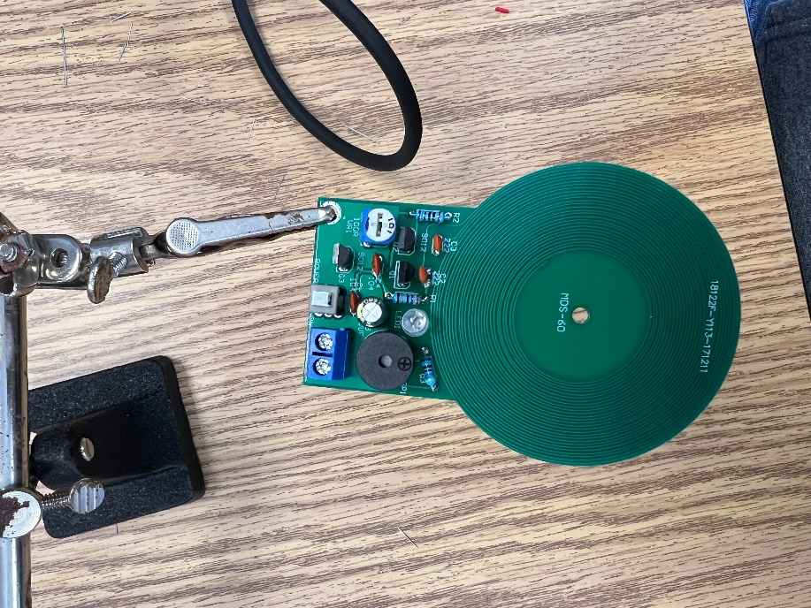 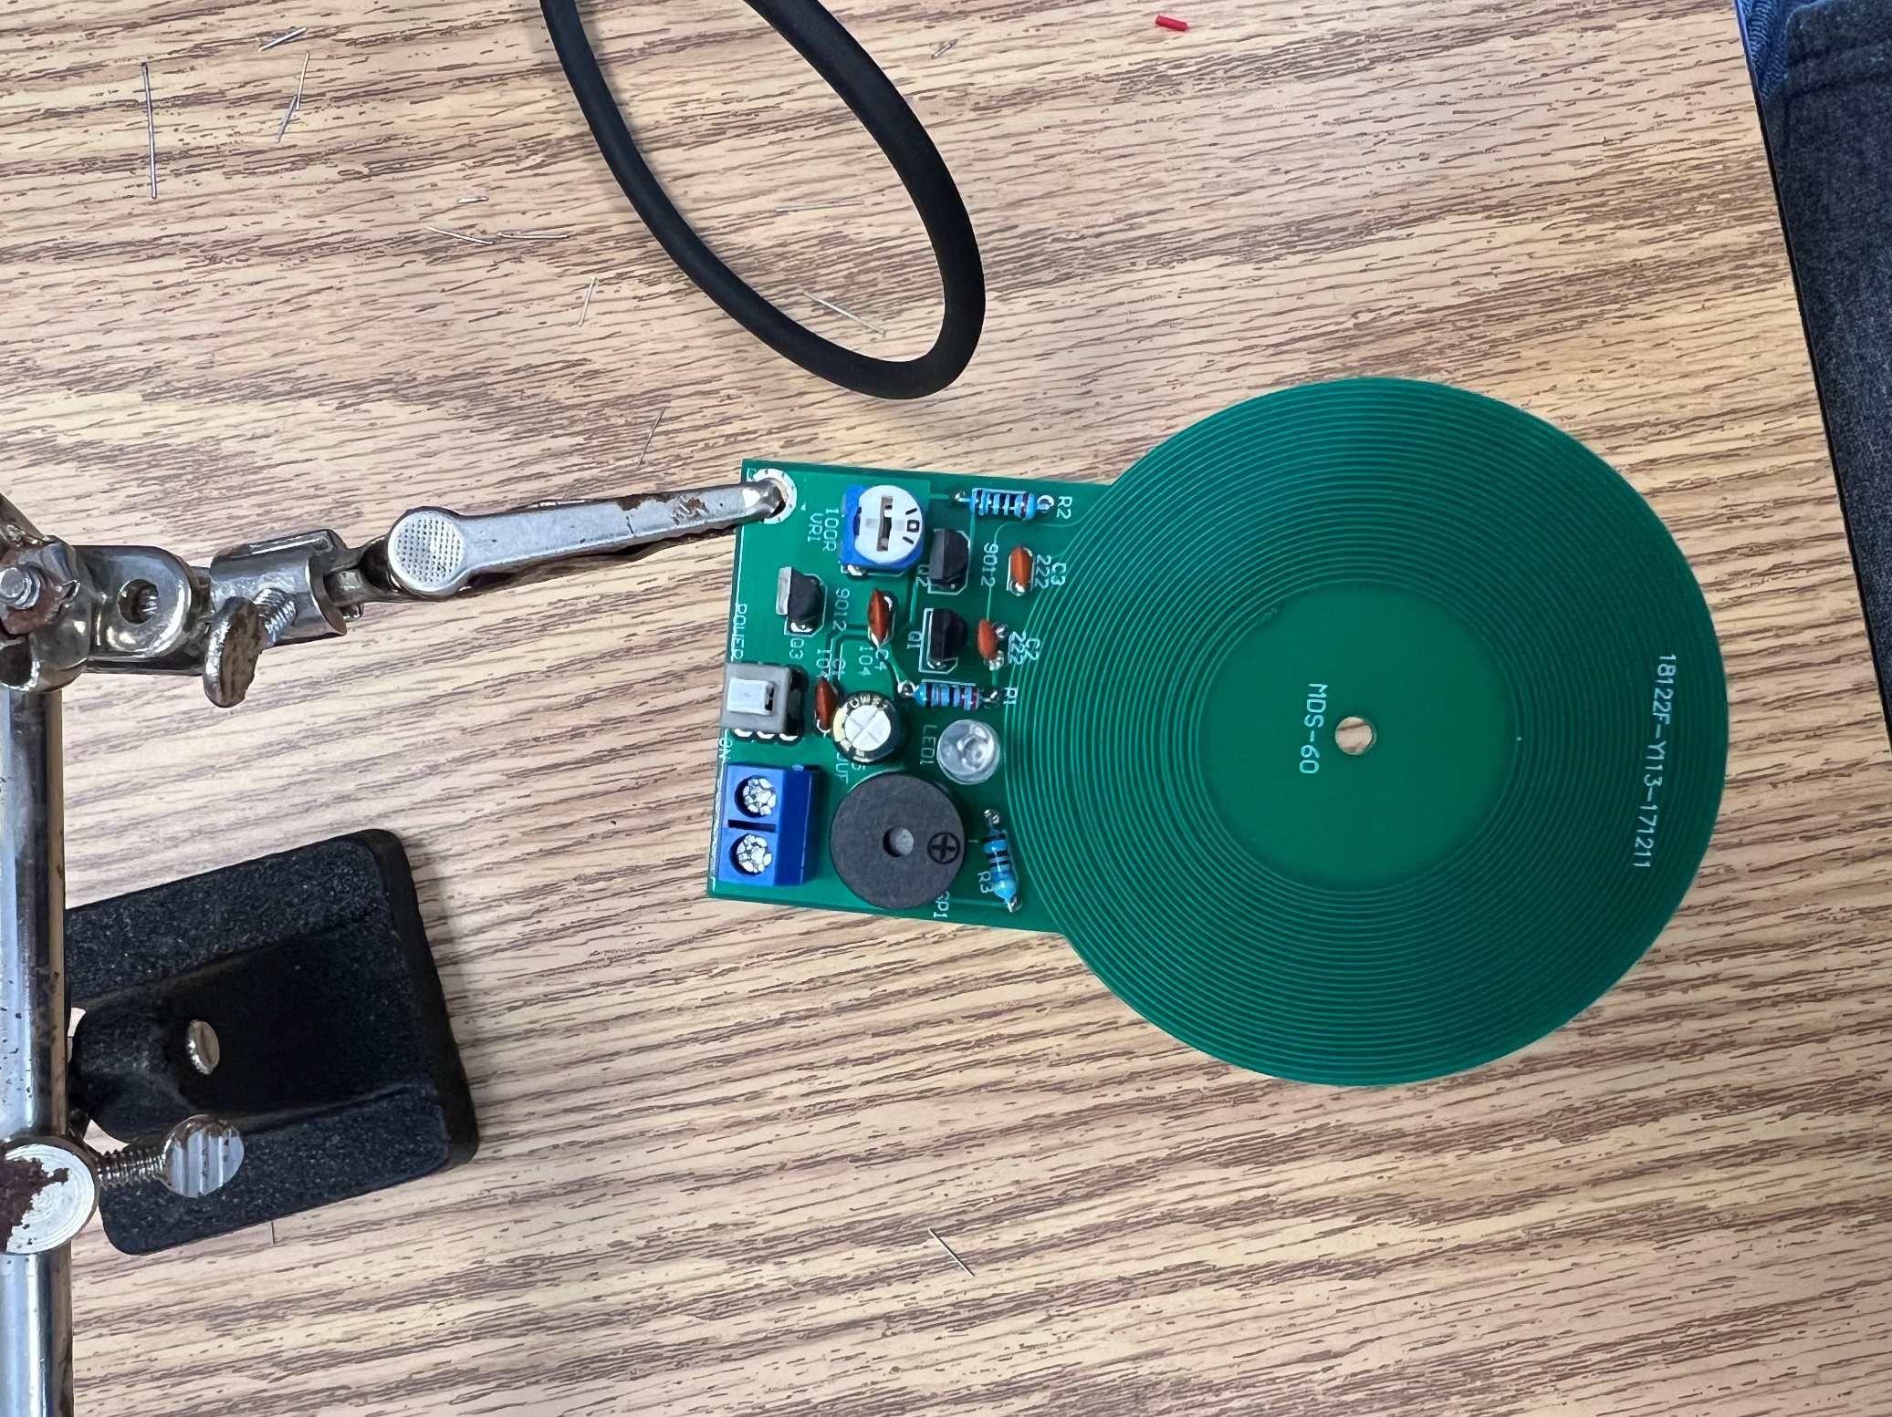

## Electrical Circuit Layout (BT)

The electrical circuit layout is our design for how all the hardware should be electrically connected. Further, this subsystem is related to the movement, pickup, and metal detection systems because they each need to be physically connected and interfaced together. This subsystem has been started this semester but likely will not be complete until all the electronic hardware components are finalized. Our current goal is to have these components finalized by the second sprint’s completion next semester so this subsystem can be completed.

The main design constraint that has affected this subsystem was the budget. Specifically, as mentioned previously motor controllers cannot typically handle extremely high current unless they’re similarly extremely costly. Using basic circuit analysis covered in many classes Ben Trewin came up with a possible solution. In order to mitigate the high current and corresponding cost, we could connect two motors in series instead of parallel. By using this method, we needed to provide twice the voltage (24V) but the current remains constant. By contrast, if we decided to connect the motors to the motor controller in parallel, the motor controller would need to be able to handle double the current. As we progress with design, and measure how much current draw our motors actually reach, we may go back to a 12V parallel motor design. See ‘Appendix G: All Design Work à Circuit Layout’ for a visual representation of the entire circuit at present.

## Control Program (NFP, BT)

The control program is written in Python using a GUI library called kivy and it interfaces with the Raspberry Pi in order to send signals that are interpreted by the Raspberry pi as instructions. The phone GUI controller allows us to control all the hardware on the robot. This includes robot movement, claw movement, metal detection, object detection, autonomous sensor movement, and autonomous maze movement start. For this reason, it is related to all subsystems including movement, pickup, autonomy, and metal detection.

See below images for Raspberry pi control flow diagram, and images of the latest phone app. See Appendix G: All Design Work à Basic Motor Controls Code’ for original basic code snippet for proof of concept. Additionally see our GIT repository for up-to-date code and documentation of the app.

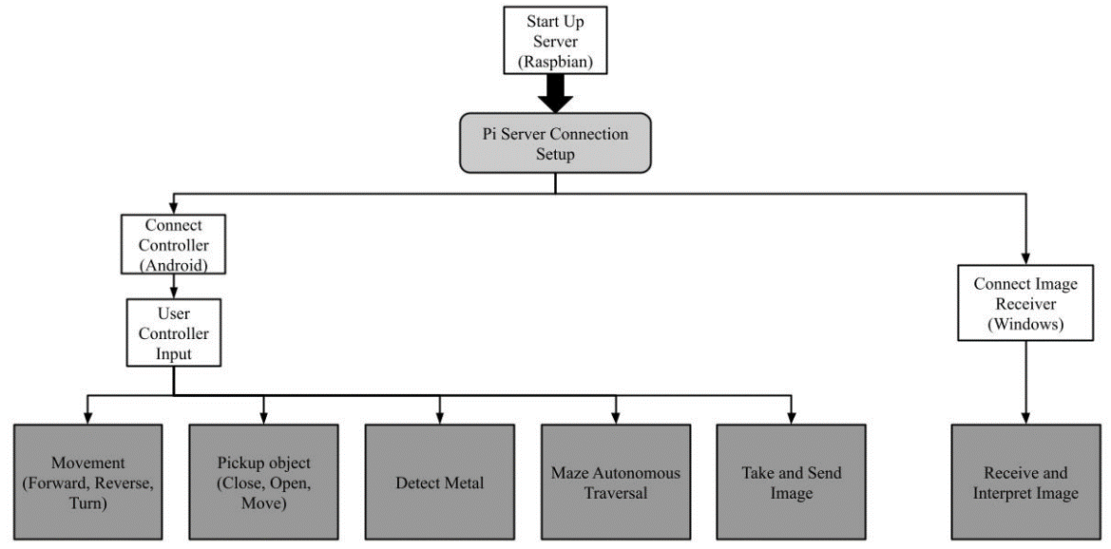

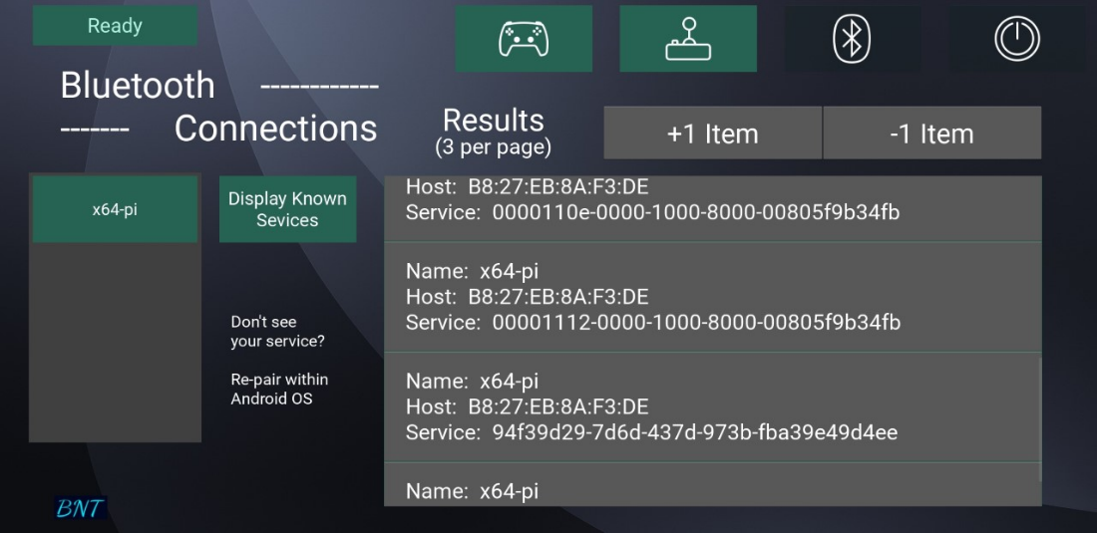

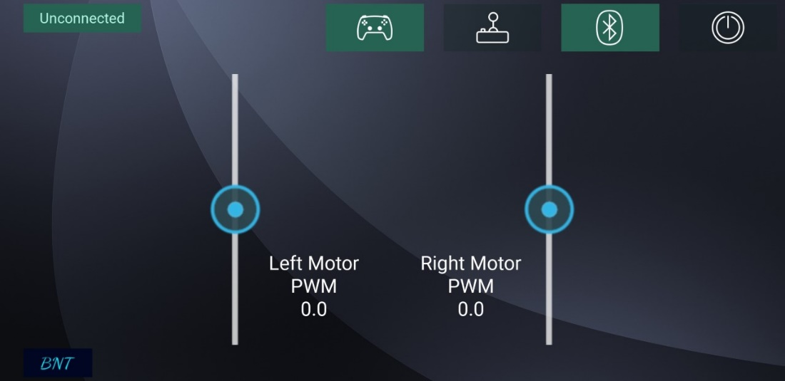

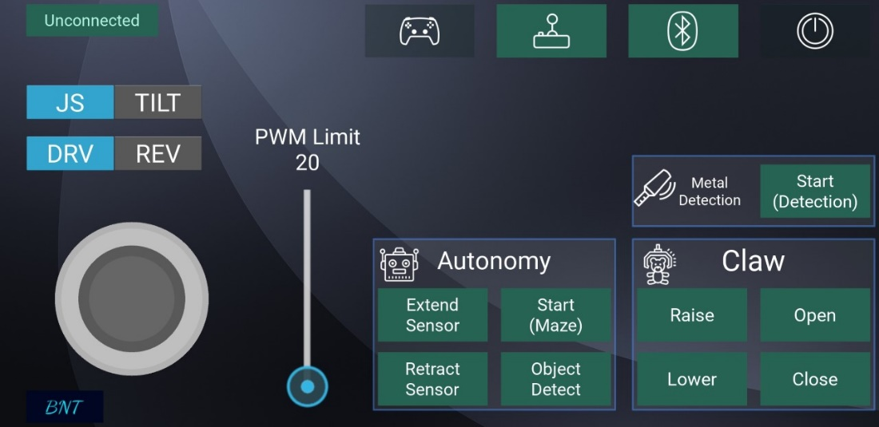

## Autonomy Program (NFP, DH)

The autonomous system uses five sensors to control the robot as it moves through the maze. It detects where the black tape on the ground is and follows an algorithm that we designed. This algorithm takes in the sensor data and sends signals to the motors to tell it what its next move should be. We wrote this in Python and use the Raspberry Pi as the main controller.

# Conclusion (DH and NFP)

This proposal has demonstrated the SEC F22-21-BOE1 team’s design for a partially autonomous search and rescue robot for Boeing. Our design consists of four motors that move the robot via timing belts and pulleys. The robot is controlled using a Raspberry Pi and motor controllers. The main goals of the robot are to move in different terrains, climb over objects, pick up objects, autonomously move through a maze, amongst other tasks. These goals are to be achieved while maintaining a budget of $1000. After two semesters of work, we were able to get it fully-functional and presented to the faculty. We would like to thank Evan Ehrenheim, Prof. Cubley, and all others who have helped us throughout this project.

# Appendix A: References (All)

|  |  |
| --- | --- |
| [1] | W. Wang, W. Dong, Y. Su, D. Wu and Z. Wu, "Development of Search-and-rescue Robots for Underground Coal Mine Operations," *Journal of Field Robotics,* 2013. |
| [2] | A. Denker, "Design and Implementation of a semi-autnomous Mobile Search and Rescue Robot," *IEEE,* 2017. |
| [3] | R. Krzysiak and S. Butail, "Information-Based Control of Robots in Search-and-Rescue Missions with Human Prior Knowledge," *IEEE,* vol. 52, no. 1, 2020. |
| [4] | P. Ninja, "Force Needed to Raise Wheel Onto a Curb," 14 December 2017. [Online]. Available: https://www.youtube.com/watch?v=-mLs94CNV_A. [Accessed 14 September 2022]. |
| [5] | robotshopmascot, "Drive Motor Sizing Tool," RobotShop Community, 3 June 2013. [Online]. Available: https://community.robotshop.com/blog/show/drive-motor-sizing-tool. [Accessed 19 September 2022]. |
| [6] | cbenson, "How to Make a Robot - Lesson 5: Choosing a Motor Controller," Robotshop Community, 17 September 2018. [Online]. Available: https://community.robotshop.com/tutorials/show/how-to-make-a-robot-lesson-5-choosing-a-motor-controller. [Accessed 4 November 2022]. |
| [7] | M. O'Hanlon, "Blue Dot," bluedot, [Online]. Available: https://bluedot.readthedocs.io/en/latest/index.html. [Accessed 2022 1 December]. |

# Appendix B: Block Diagram (BT)

Subsystems Development Diagram

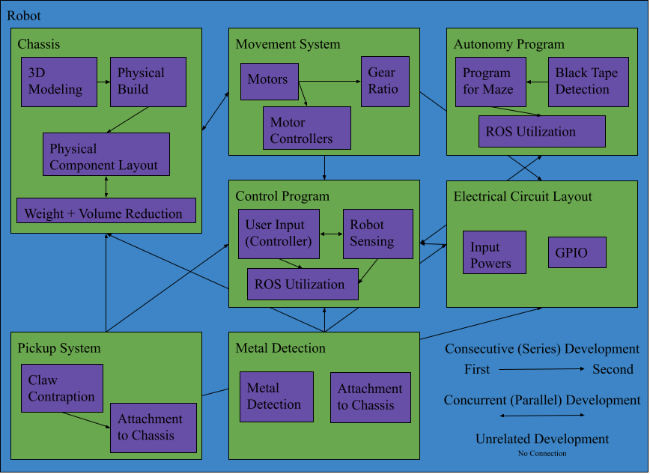

# Appendix C: House of Quality (DH)

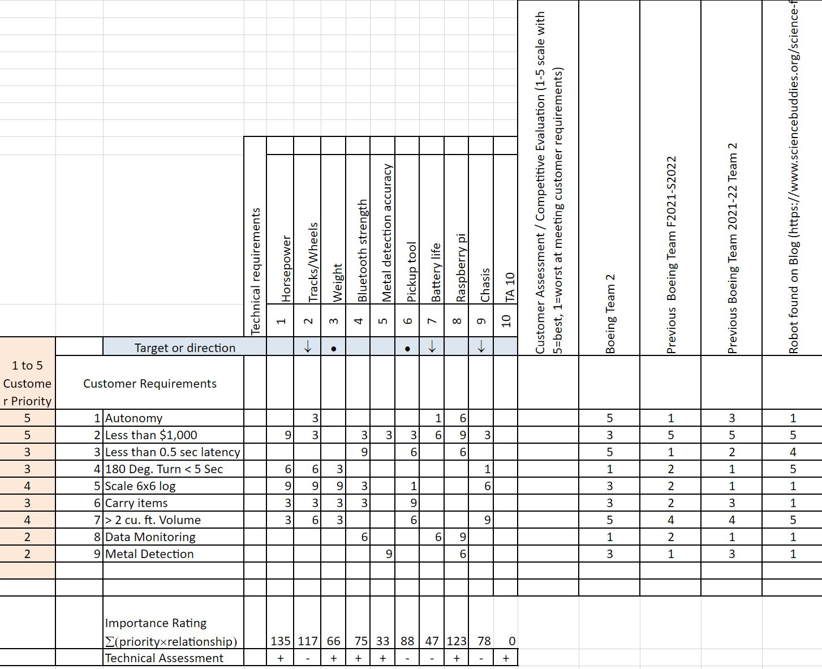

# Appendix D: Organizational Chart (DH)

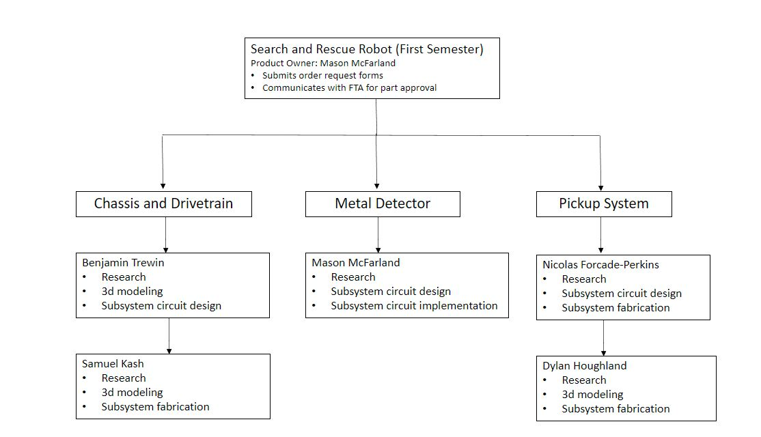

# Appendix E: Sprint Breakdown (DH)

Fall 2022 Semester (completed)

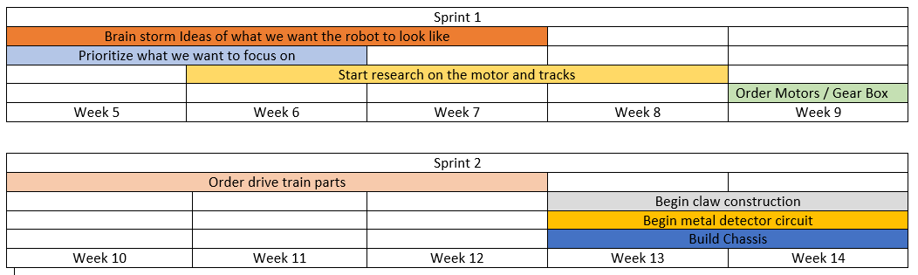

Spring 2023 Semester

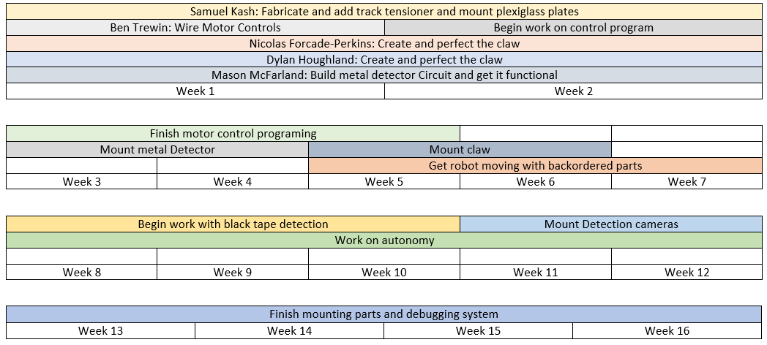

# Appendix F: Budget (NFP)

A summary of our budget is provided below.

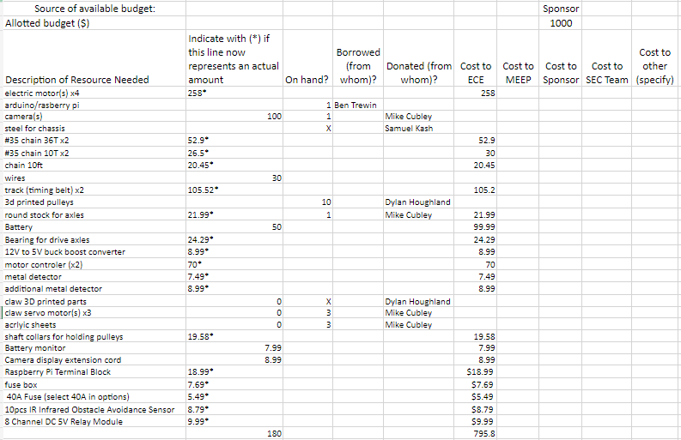

# Appendix G: All Design Work

## Metal Detector Circuit/Implementation (MM)

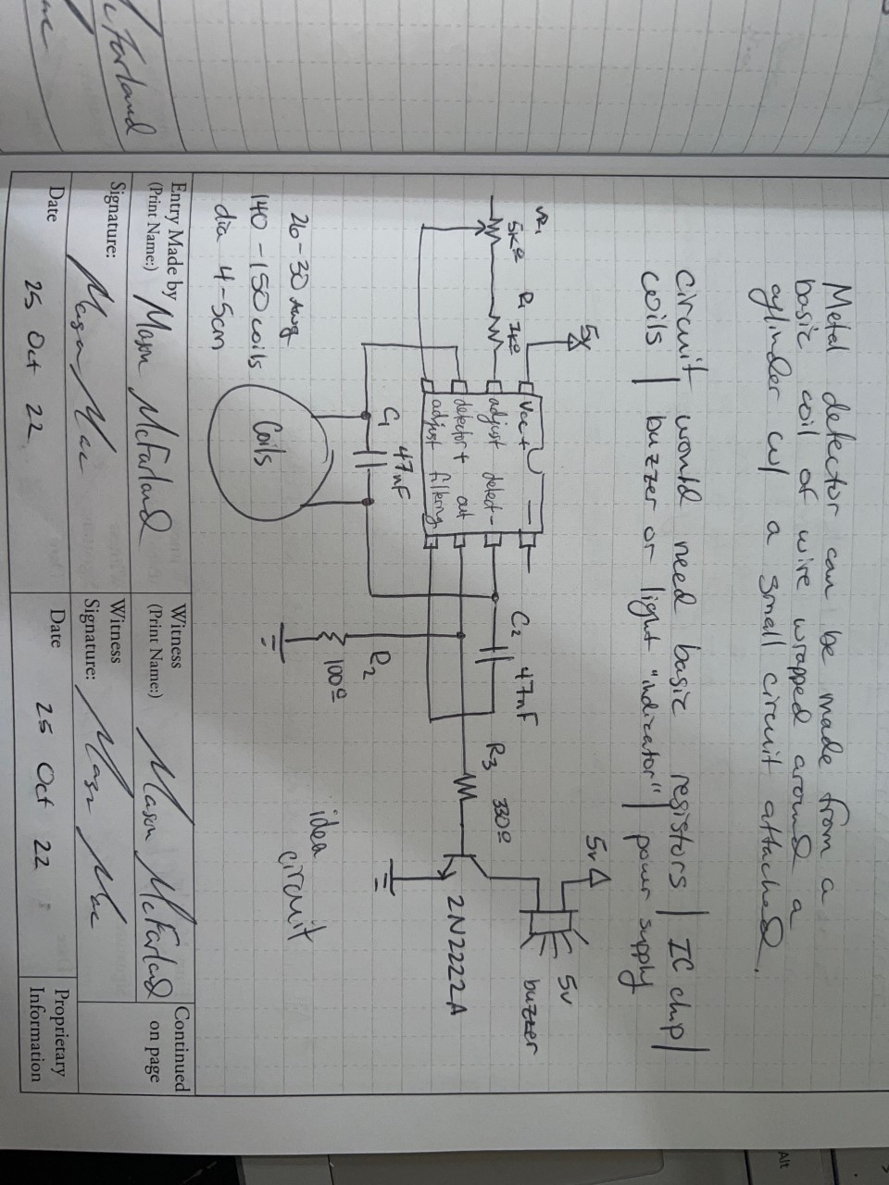

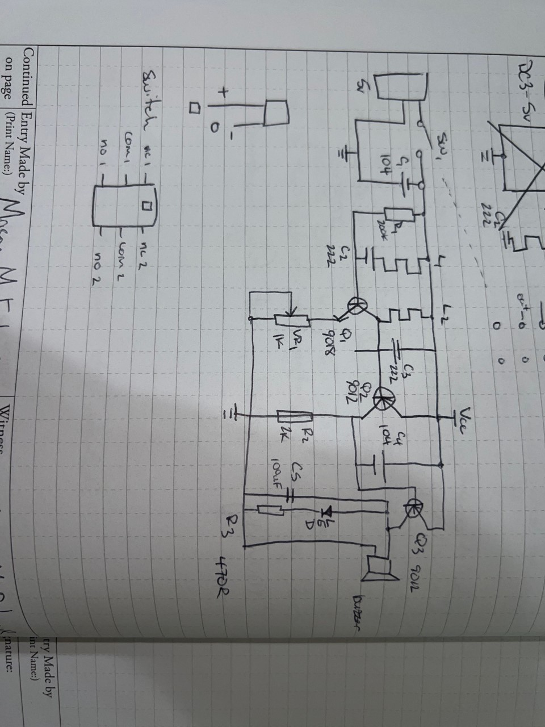

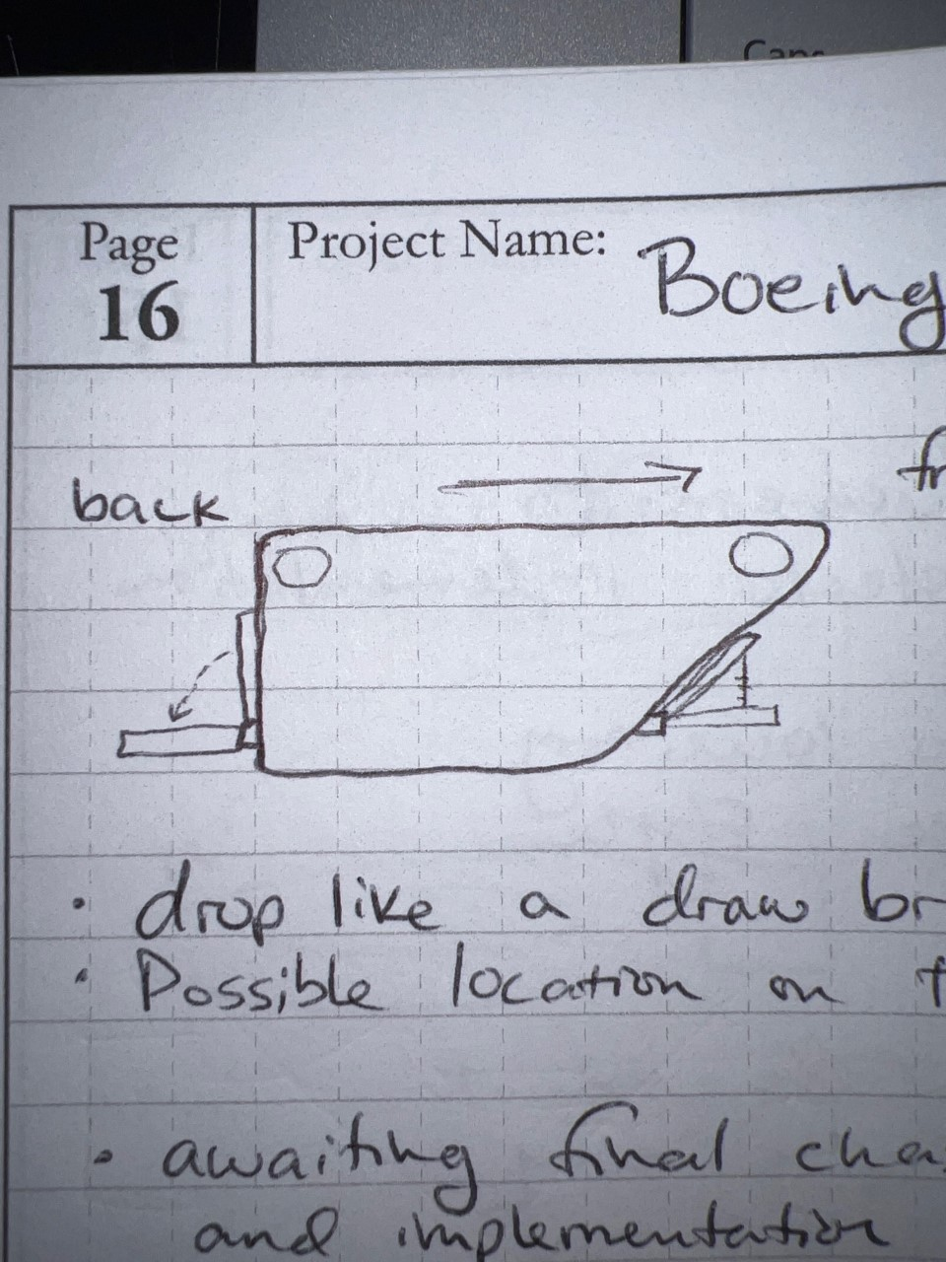

## Wheel Physics (BT)

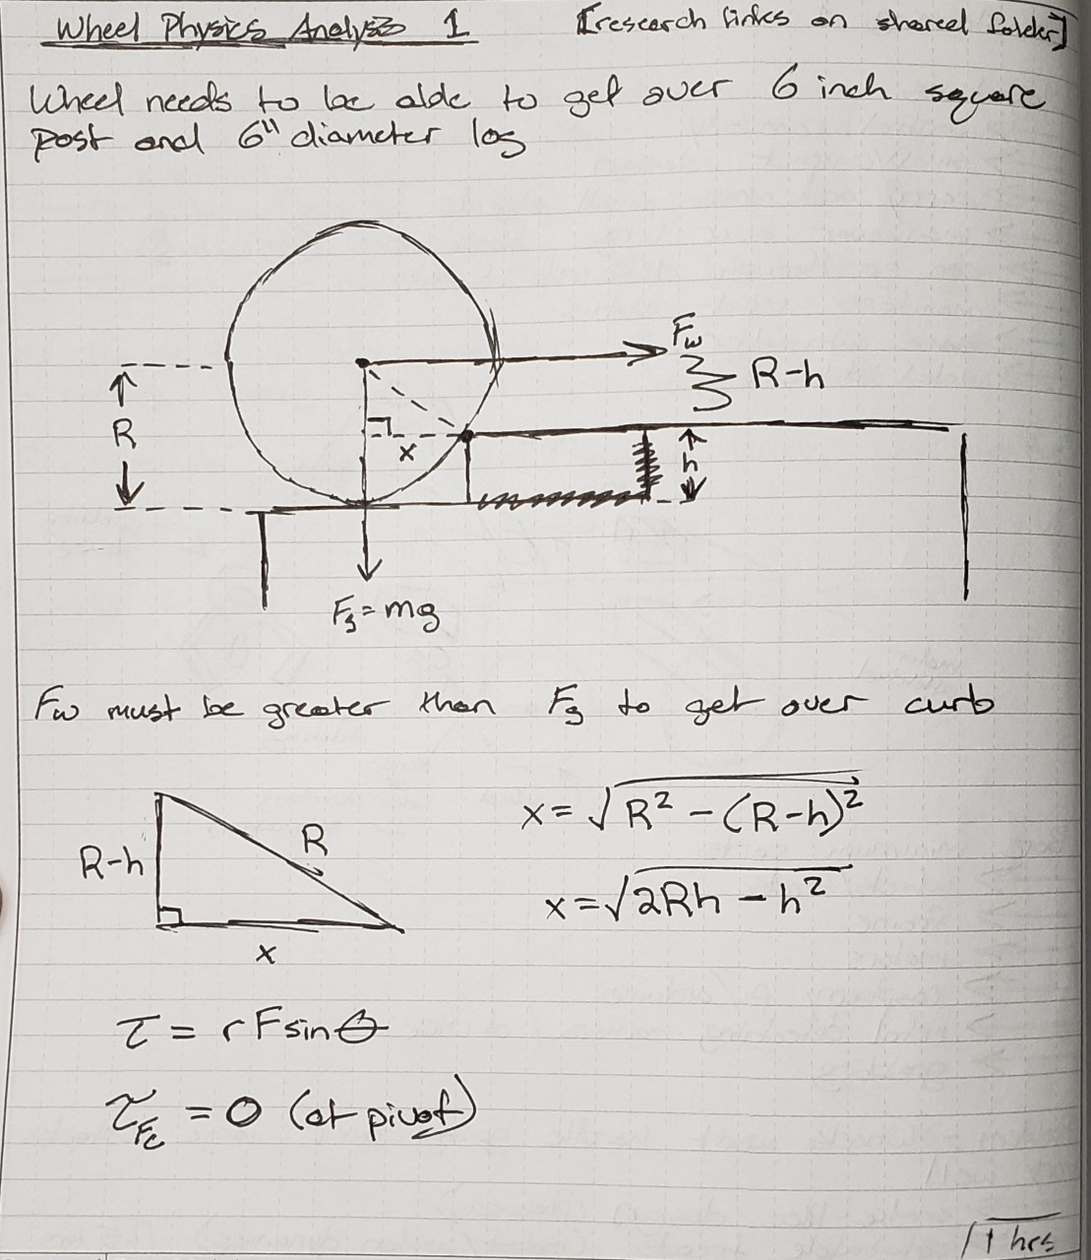

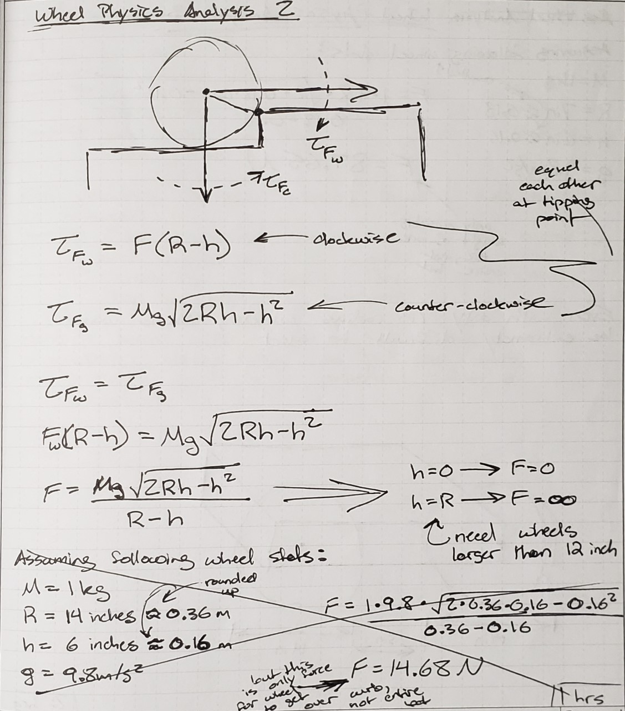

## 3D Models of Chassis (BT)

Version 1 – Initial idea and shape of design

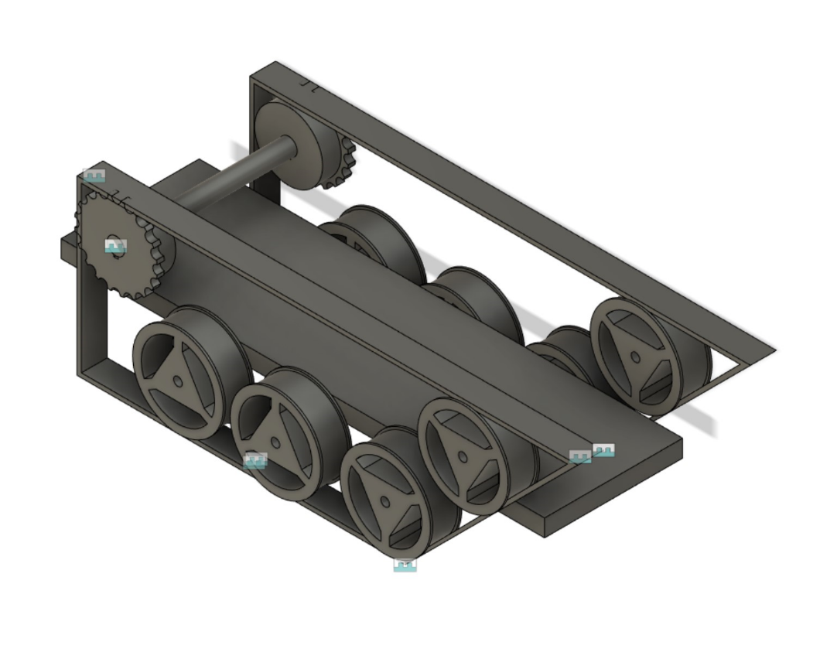

Version 2 – Adding more of the movement logistics to design

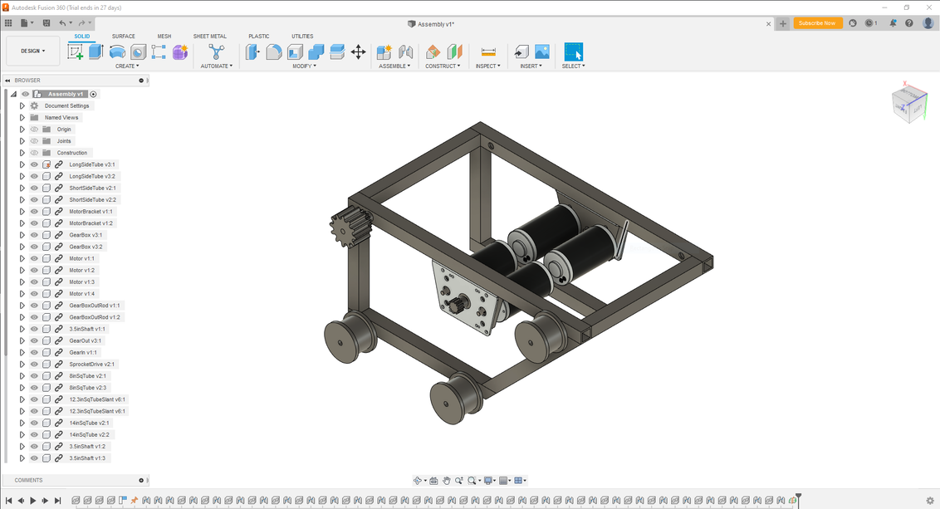

Version 3 – Made design more compact and more elaborate, quite close to our finalized chassis

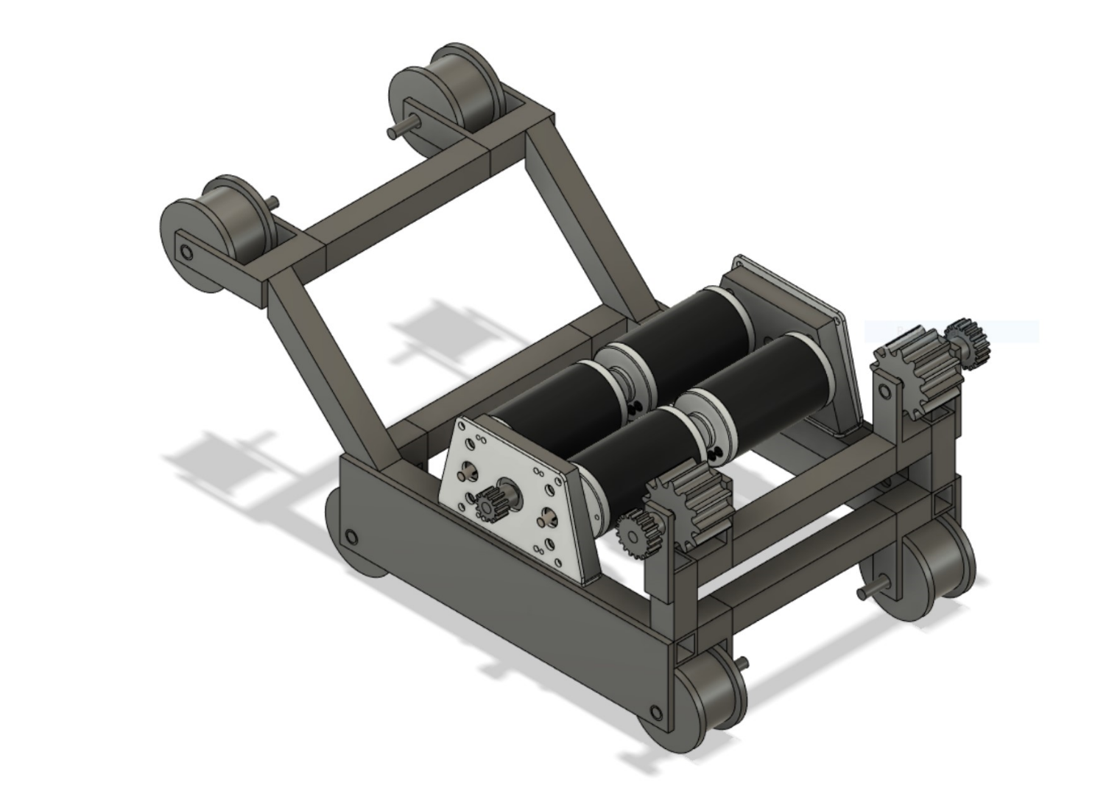

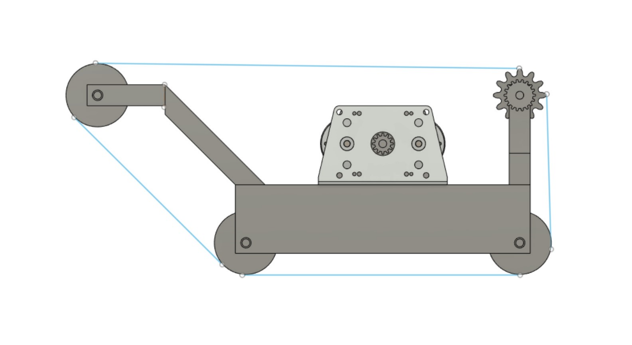

## Basic Motor Controls Code (BT)

A snippet of motor control code that is fully functional with the test setup shown in control program subsystem analysis. It allows for changing of speed and direction of a single motor by interfacing the raspberry pi, a motor controller, and a motor.

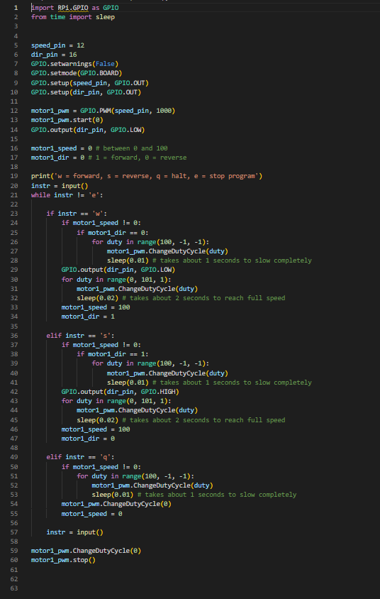

Circuit Layout (BT)

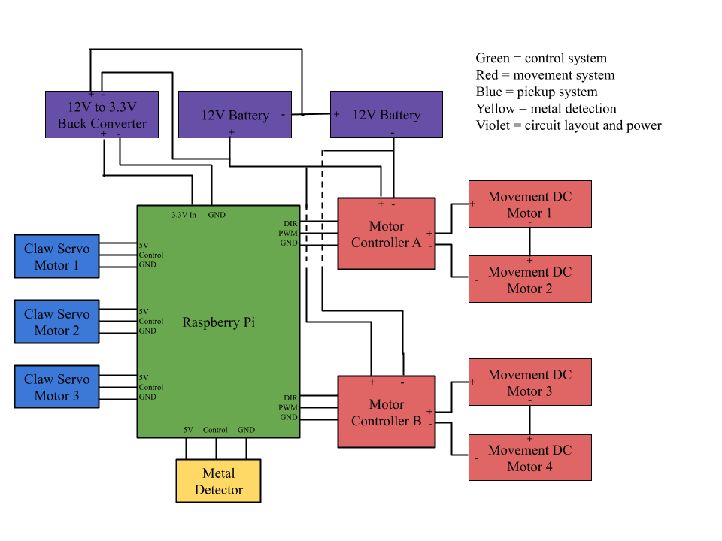

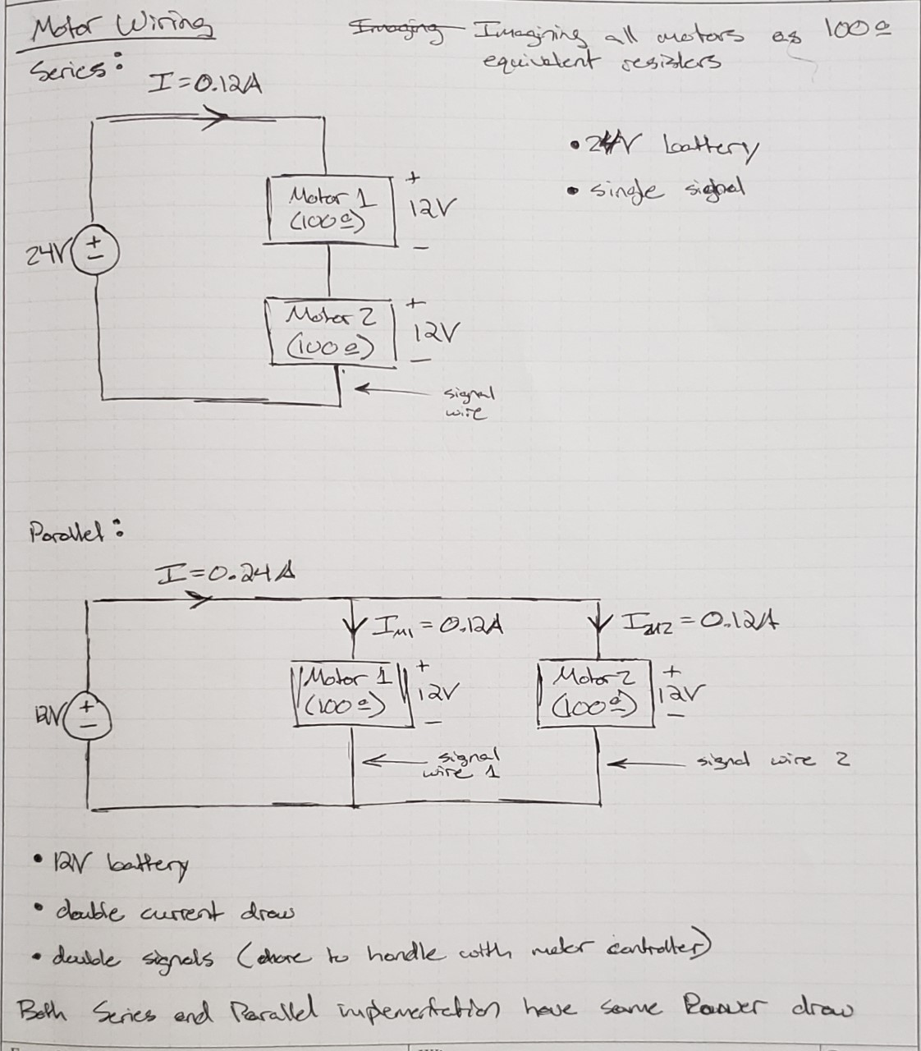

# Appendix H: User Manual (NFP and BT)

1. Ensure all the switches are switched on, on the robot
2. Run server code on the Raspberry Pi (if it doesn't automatically run on startup)
3. Open the Android controller app on a phone
4. On the phone, click the Bluetooth icon and connect to the Raspberry Pi. It should be the one labeled with a UUID ending in “ee” (can be specified within code)
   1. If you do not see the device or service, forget and then repair the two devices while the server code is running
5. Click on the controller icon to navigate to the complex controls screen
6. Move the robot as desired using tilt and joystick options
   1. Note that the tilt movement is currently only functional for forward movement
   2. The PWM slider allows a simple method to cap the maximum speed at the indicated percentage (PWM)
7. Click the buttons labeled for whatever other functionality as needed (these include object detection, autonomous operations, claw movement, and metal detection)
   1. Note to allow identification of objects as desired, a Windows program must also connect to the Raspberry Pi via Bluetooth. After which, pressing the object detection button will send images to the windows device for analysis

# Appendix I: Technical Manual (NFP)

Frequent Issues and Solutions:

If there are issues with any specific parts of the robot, first ensure that it is connected correctly and receiving power.

If the entire robot stops working, first try completely disconnecting the battery and reconnecting it. If this doesn’t work, it likely means the battery is dead and needs to be charged.

If the track slips off of the roller, unscrew the tension roller. This will cause the tracks to loosen and give you the ability to align them before retightening the tensioner.

If the autonomous system isn’t working, first ensure that the outer two sensors are pointed a bit outwards and the inner three are pointed slightly inwards. If it is still not working, then retune the sensors by turning off the motors and running autonomy. Place a piece of black tape under and ensure that it gets the correct value. If it is not getting the expected result, use a screwdriver to tune the potentiometer.

The wiring system for the robot is seen below.



The circuit for the metal detector is seen below. If there are any issues, ensure that all parts are receiving power.



Appendix J: Parts Plan (NFP)

# Appendix J: Parts Plan (NFP)

* Raspberry Pi – Return to Dylan
* Claw – Donate
* Metal Detector – Donate
* Switches – Return to Samuel
* Everything else - Donate

# Appendix K: Communication (BT)

Updated Boeing Score sheet communicated to us by our FTA.

